NOTE: The quantity and complexity of each station will depend on the number of volunteers available. There are certain stations that can only be run by qualified members of the Biomechatronics Lab (http://BiomechatronicsLab.ucla.edu), as the demonstrations involve expensive equipment and customized set-ups.

When | What | Supplies | Responsible party
 | Pack equipment into cars. | - Demo materials  - Lab t-shirts  - Camera
 | Drive everyone to _________.
- Sign in at front office.
- Borrow a cart.
- Set up demonstrations (30-45 min.)
 | Optional, for entire, multi-class group:  - Introductions (all lab members)  - Videos: (Veronica)  - Demo: Indoor RC quadcopter flight? (Randy)  - Split up into individual stations. | - Projector (to be provided on-site)  - Computer with .ppt and videos  - RC quadcopter
(and repeating every 15 min.) | Station #1: Robot hands  - Prompt: “Where are the muscles that move your fingers? How do they transmit their forces?”  - Hands-on: Pass around plastic tendon-driven hand model  - Demo: Show Shadow Hand in case (for viewing only)  - Demo: Show BairClaw in action (for viewing only) | - BairClaw with computer and peripherals  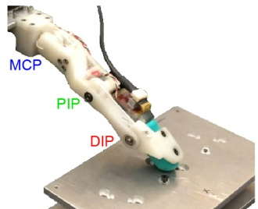  - Shadow Hand  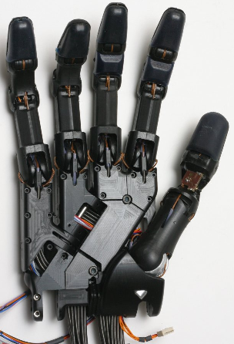  - Plastic tendon-driven hand model  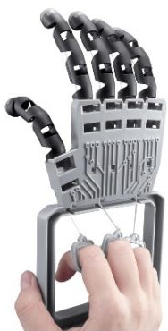
(and repeating every 15 min.) | Station #2: Tactile sensing  - Hands-on: Ask students to reach into boxes and, without looking, guess which ball is shaped like a golf ball, tennis ball, basketball, and Earth. Can have students raise their hands to vote for the item matched with each letter “A”, “B”, “C”, and “D.”  - Prompt: “How did you identify the objects without looking?”  - Hands-on: Take two volunteers and have each one put on a glove. Mix up the balls in the boxes and ask them to identify the objects with their gloved hands.  - Prompt: “Why did they have a hard time identifying the balls this time?”  - Hands-on: Pass around tactile sensor skin prototypes  - Demo: Describe and show off the BioTac sensor (for viewing only unless the students are well-behaved, in which case they may squeeze the BioTac held by a lab member) | - Projector (to be provided on-site)  - Laptop for running LabVIEW GUI  - BioTac tactile sensor with peripherals  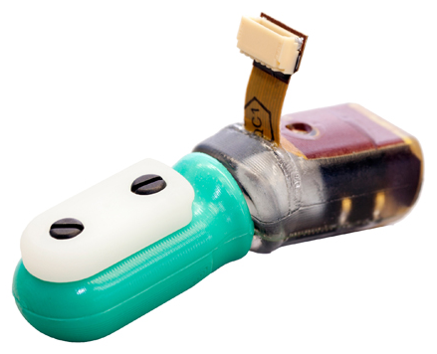  - Touch-but-don’t-look boxes (with hidden objects)  - Kid-sized gloves  - Tactile sensor skin prototypes in a closed petri dish
(and repeating every 15 min.) | Station #3: Make-a-finger  - Prompt: “Where are the muscles that move your fingers? How do they transmit their forces?”  - Hands-on: Demonstrate the straw finger that the students will each make and show them how.  - Thread a ribbon through a straw.  - Tape the ribbon to the fingertip with the ribbon on the notched (flexion) side of the fingertip.  - Prime the straw by manually bending the straw at each of the joints.  - Move the finger by holding the base of the straw with one hand and pulling on the ribbon with the other hand.  - Think of fun and interesting things you can do with your artificial finger (e.g., say “come here” to someone, scratch your nose, knock over something lightweight, wrap the finger around something). | - Plastic skeleton hand model  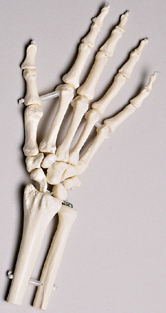  - Demo straw fingers  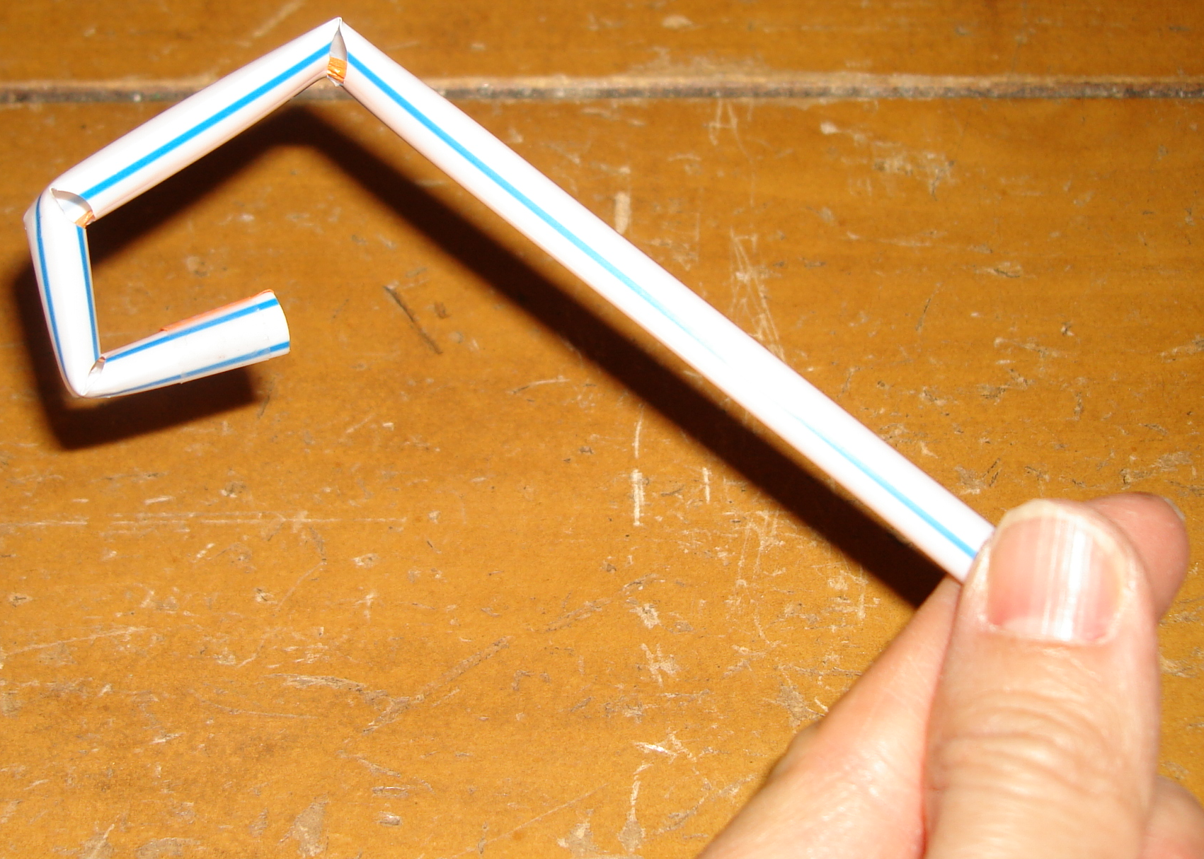  - Pre-notched straws  - Ribbon  - Tape
(and repeating every 15 min.) | Station #4: Dream your own robot  Hands-on: Ask the students to design, draw, and describe their own robots. The robot can be inspired by something they’ve seen, something they would like to see, or something they would like a robot to help them with in their own lives. After they’ve drawn their robots, ask the students to add captions to their pictures. | - Paper  - Writing implements  - Coloring implements
(and repeating every 15 min.) | Station #5: Prosthetic hands and arms  - Videos: Show videos of various methods of control: electromyography (EMG), peripheral nerve interfaces, brain-machine interfaces, targeted reinnervation, electroencephalography (EEG)  - Demos: Body-powered split-hook, Myoelectric prosthesis | - Projector (to be provided on-site)  - Computer with .ppt and videos  - Body-powered split hook  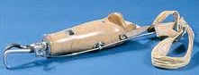  - Myoelectric prosthesis  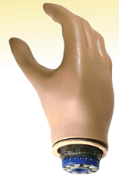
(and repeating every 15 min.) | Station #6 [NEW…would need to develop]: Robot hand/arm coordination  - Prompt: “What are some different ways that humans can control robots?”  - Videos: Show videos of various methods of control: joystick, laser pointer, speech, eye gaze, electromyography (EMG), peripheral nerve interfaces, brain-machine interfaces, targeted reinnervation, electroencephalography (EEG) [REMOVE videos that overlap with prosthetic hand station, if necessary)]  - Demo:  - Teach a robot arm a pick-and-place motion (e.g., pick up a water bottle and move it).  - Replay the arm motion.  - Set up a student volunteer with EMG surface electrodes on his/her biceps and/or triceps muscles.  - Let the student control the opening and closing of the robot hand using his/her muscles. | - Projector (to be provided on-site)  - Computer with .ppt and videos  - Robot arm/hand with computer and peripherals  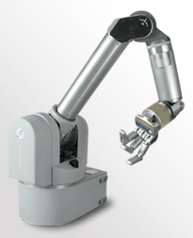  - EMG amplifier and peripherals  - Surface EMG electrodes  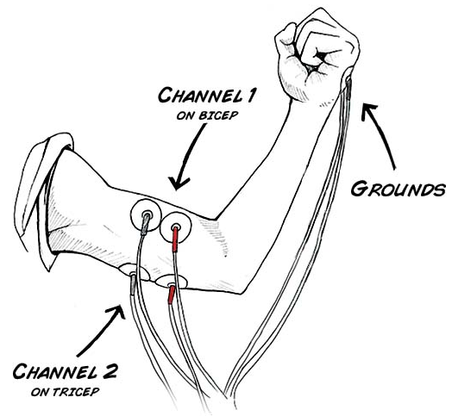  (backyardbrains.com)  - Water bottle  - Caution tape

